**PHINMA UPANG COLLEGE URDANETA**

Nancayasan, Urdaneta City

Accountancy Business and Management

**12 ABM 3**

**MARKETING PLAN**

Presented as Partial Fulfillment of the Requirement for

**PRINCIPLES OF MARKETING**

Submitted to:

**ARNEL Z. BAUZON, MBA**

Professor

Submitted by:

**RAVEN LHEE D. GINEZ** **KEN JULIUS M. MUNAR**

**PRECIOUS MAE J. PAGARAN** **QUINCY A. TAMAYO**

**LYKA AMOR A. GUARIN** **JHEMALYN T. NISPEROS**

**ARIANNE MAE C. QUIDASOL** **JOHN IVAN T. SABADO**

**BJAY M. LAUREANO** **RICHARD RAPHAEL R.**

**ZAPATEROS**

**ARISA N. ONODERA**  **GERLIE B. ORBIZO**

ABM Students

First Semester

Academic Year 2020 – 2021

**T A B L E O F C O N T E N T S**

**PAGE**

**COVER PAGE**  i

**TABLE OF CONTENTS**  ii

Executive Summary 1

Products and Services 2

Mission and Vision 4

Logo, Tagline and Marketing Materials 5

Customer 6

Competitors: Market Positioning 9

Competitor Analysis 10

SWOT Analysis 11

Product Versus Top Competitor 14

PESTEL Analysis 15

STDP Marketing 17

Product Positioning 21

Marketing Objective 22

Marketing Mix 23

**Executive Summary**

**Telehealth and Mental Resilience App by HappyHealth.io**

Many people's lives have been massively changed as a result of technological advancements, including how they communicate with one another. Social media has evolved into a game-changing technological phenomenon that has made interactions and information sharing far more convenient. This pandemic led us to become more high-tech. Technology gives us opportunity and keeps us surviving in the daily competition especially during this pandemic. The COVID-19 pandemic worsened mental health disparities as well as our society’s digital divide. During this pandemic, emergency measures that allowed for the deployment and development of telehealth services aided in improving mental health equity by boosting access to and utilization of critical mental health and behavioral health support services. Our product, Telehealth service and mental resilience app is basically a platform that can be used to navigate your health and help individuals mentally cope up with depression, crisis, and pandemic that are happening right now. It also enables the users to enjoy mental resilience even in times of the highest turmoil and uncertainty. This app helps to improve thought processes, confidence, and mood without having to type a single line.

**Products and Services**

Telehealth is the use of digital information and communication technologies, such as computers and mobile devices, to access health care services remotely and manage your health care. These may be technologies you use from home or that your doctor uses to improve or support health care services. Consider, for example, the ways telehealth could help you if you have diabetes. You could do some or all of the following: Use a mobile phone or other device to upload food logs, medications, dosing and blood sugar levels for review by a nurse who responds electronically. Watch a video on carbohydrate counting and download an app for it to your phone. Use an app to estimate, based on your diet and exercise level, how much insulin you need. Use an online patient portal to see your test results, schedule appointments, request prescription refills or email your doctor. Order testing supplies and medications online. Get a mobile retinal photo screening at your doctor's office rather than scheduling an appointment with a specialist. Get email, text or phone reminders when you need a flu shot, foot exam or other preventive care. The goals of telehealth, also called e-health or m-health (mobile health), include the following: Make health care accessible to people who live in rural or isolated communities. Make services more readily available or convenient for people with limited mobility, time or transportation options. Provide access to medical specialists. Improve communication and coordination of care among members of a health care team and a patient. Provide support for self-management of health care. Mental resilience Although material resources, socioeconomic position, health behaviours and genetic inheritance are significant health determinants, known risk factors do not explain all the variation in mortality. Morbidity or in other outcomes e.g education, crime, alcohol and drug misuse. So known risk factors are only one part of the picture. Conversely, not everyone who is exposed has poor outcomes. In particular, classical epidemiology does not explain the factors and mechanisms that protect some individuals and communities notwithstanding adverse conditions/ exposure. For example, the striking variation in rates of nearly all mental health problems both within and between countries raises important questions about what protects some individuals and groups from mental illness and highlights the need for more studies based on population rather than clinical samples. An emerging literature on salutogenesis, health assets, resilience and capability is centrally concerned with positive adaptation, protective factors and assets' that moderate risk factors and therefore reduce the impact of risk on outcomes (Bartley et al forthcoming). A WHO paper exploring the potential of health assets describes them as follows: high health assets producing a buffer' or 'resilience factor in disease risk exposure. High health assets producing health as a positive entity (quality of life-wellbeing).

**Mission and Vision**

**MISSION**

Our mission is to provide, through customer engagement, outstanding services and solutions that advance the capabilities of our product, empower staff to provide exceptional services, enrich the users experience, and effectively manage and protect data from the users.

**VISION**

HappyHealth.io will strive to provide a best features that will be enjoyed by many people and especially the one's who needed support and assistance. We also want to inspire hope and contribute to health and well-being by providing the best care to every people that trust us.

**Logo and Marketing Materials**

**LOGO**



The type of logo that we use is icon-based. HappyHealth.io wants to portray calm ambience and to attract them to look at our product. People may want a quieter, softer, comforting approach in our logo so that they will have no doubt in installing it.

💙

❤️

2

**MARKETING MATERIALS**

* **Web Sites** – It is the one of our marketing tool for our business simply because it serves as a virtual equivalent of a physical business for the 3 billion internet users worldwide. We can use this opportunity to let our customers know what is our product and make them use it without regret.
* **Advertising Materials -** It offers planned and controlled message. It can contact and influence numerous people simultaneously, quickly and at a low cost per prospect. We can use this to minimize the expenses for advertising.

**Customer**

HappyHealth.io has developed target marketing plans and help to ensure that our product meet the needs of our intended audience.

1. People that maintain their body physically fit
2. People who has various diseases especially now in pandemic
3. Workaholic people
4. People who has problem with their health like depression, anxiety, etc.

| **Kind of Customer** | **Why they uses this app** |
| --- | --- |
| 1. **People that maintain their body physically fit** | It features a personal account, setting goals, actual activity tracking, and social elements. It is ultimately judged by their value to the healthcare system; their ability to improve the individual experience and outcomes as well as reduce the costs of care. |
| 1. **People who has various diseases especially now in pandemic** | When you are already feeling other illnesses, especially that it affects your mental health, this app can help you feel relaxed and can ease the stress in your life. This app is important to our customers because we can use it in our daily life to entertain ourselves. Especially in this time of pandemic, many people need this app. As what we can hear from the news, Covid-19 is real and the people's minds are nervous, so instead of panicking, let's use this app since it can surely help each and every one of us. |
| 1. **Workaholic People** | If you are a workaholic person, this app can help you to fight depression. For instance, you are a supervisor in a company that is bombarded with works, sometimes you feel anxious because of the pressure and it can affect on how you think. And so, that is all the more reason why we need this app because it helps us feel more relaxed. |
| 1. **People who has problem with their health like depression, anxiety, etc.** | If nearby doctors are available, they can contact them so they will have a consultation. Hospitals are crowded right now. That's why it is hard for them to socialize with other people. Even in the simplest word can help these customers. |

**Competitors**

**Market Positioning**

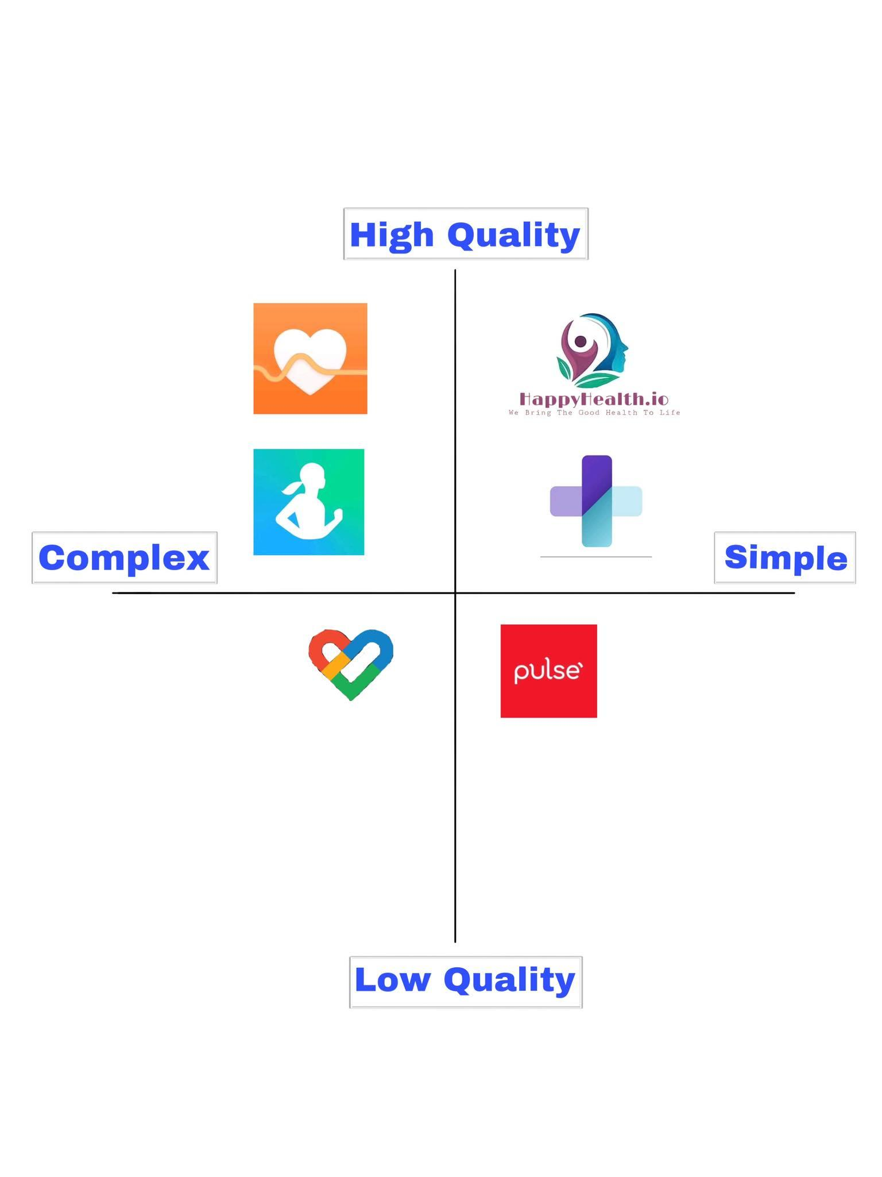

According to the image, the 6 top corporations: HappyHealth.io, HealthNow, Samsung Health, Huawei Health, Pulse and Google Fit have the highest ratings regarding those app developments. 2 corporations offer high-quality and simple products, and the other 2 corporations offer high quality and complex, other one on simple but low quality, and another one on complex but low quality in their respective categories. Those are their categories in market positioning.

| **HAPPYHEALTH.IO COMPETITOR ANALYSIS** | |
| --- | --- |
| Competitor | Product they offer versus HappyHealth.io |
| 1. Pulse | Pulse Application versus HappyHealth.io Application |

| **HAPPYHEALTH.IO SWOT ANALYSIS** |
| --- |
| **STRENGTHS** |
| 1. Improves users engagement with remote monitoring  * The increasing role of consumerism and value-based reimbursement in healthcare has led hospitals and health systems to emphasize new ways of interacting with their patients to engage them in self-care.  1. Cuts user costs  * With a telehealth visit, the host comes to the users on their phone, laptop, or another digital device. Oregon Health and Science University saved their patients $6.4 million annually in travel costs by implementing a telemedicine program.  1. Recording measurements  * Recording measurements like your weight, food intake, blood pressure, heart rate, and blood sugar levels can easily monitor manually. |
| **WEAKNESSES** |
| 1. Still needed an head on consultation  * It isn't possible to do every type of visit remotely. You still have to go into the office for things like imaging tests and blood work, as well as for diagnoses that require a more hands-on approach.  1. Protecting user's data  * Hackers and other criminals may be able to access a user's data, especially if the user gave access to others on a public network or via phishing.  1. Technological concerns  * inding the right digital platform to use can be challenging. Also, a weak connection can make it difficult to offer quality care. |
| **OPPORTUNITIES** |
| 1. Consistent customer growth  * People continuously purchasing products so Telehealth app should take advantage of this situation by offering different activities  1. Users may have the opportunity to have a healthy lifestyle and become more fit. It also develops strategies to help you to achieve your lifestyle. 2. Telehealth also have the opportunity in the midst of pandemic because users cannot go out and they have no choice to try our product. It also helps us to grow HappyHealth.io and to extend the benifits for the users. |
| **THREATS** |
| 1. Competitors with more resources and name recognition 2. other health apps 3. Our customer can transfer to our competitors |

**Pulse versus HappyHealth.io**

The developer, PULSE ECOSYSTEMS PTE. LTD., is established on 17 of august 2020, and until today, they are improving their application. Pulse application is powered by the AI-technology, Pulse is a health and fitness app that uses data to understand your unique needs as an individual and offers you tailor-made, relevant health insights and solutions to assist your journey to wellness. It also has features that can make you enjoy the app. It empowers you to play an active role in managing your personal health and wellbeing. Pulse is your new partner in preventing, postponing, and protecting yourself against the onset of diseases.

Telehealth and mental resilience app is basically a platform that can be used to navigate your health and help individuals mentally cope up with depression, crisis, and pandemic that are happening right now. It also enables the users to enjoy mental resilience even in times of the highest turmoil and uncertainty. Advantages of our product are underscored by its interactivity, just-in-time interventions, and low resource requirements and portability.

**PESTEL Analysis**

**Political Factors**

These factors over and over apply pressure on the selling of Apple especially in the domesticated market.

These entire things have a lot to do with the market of a particular brand.

* Governance
* Security Control
* Tariffs
* Leadership

Several countries have taken significant measures to promote people's health, and Telehealth and mental resilience applications must include nutritional information. Government tax rules can have a significant impact on the application company. The corporation must meet the criteria that arise from the formation of any political affiliations. Violence, corruption, war, and social instability are some of the other political hazards.

**Economic Factors**

As these factors play a pivotal role in the economy, it has a long-term influence on a company

* Taxes
* Monetary Policies
* Growth Rate
* Disposable Income

These are critical determinants that have a significant impact on an economy's performance. In most cases, they wind up becoming a crucial decision-maker in a company's success or failure. Software is sold in the form of a service. Free, freemium, and premium services have evolved, with some services being free but displaying advertisements and paid options for ad-free services accessible. The price pattern of a company's services can be affected by an increase in the rate of inflation in any economy. Furthermore, it has an effect on the users' purchasing power parity and causes a shift in the economy's demand and supply dynamics.

**Social Factors**

In the social step for these analyses, we have to look carefully at the social changes. We will also have to look into the cultural changes which take place in our business environment. Market research is a critical part of this step. It is vital to see the trends and patterns of society.

* Lifestyles
* Health consciousness
* Emphasis on safety
* Population growth rate
* Age distribution and life expectancy rates

**Technological Factors**

**Internet connectivity** - It’s undoubtable that in recent years global internet connectivity has been on the rise. This presents an even larger market for many companies who use the internet to connect with their customers. **Security in app** - Technology has spawned numerous security risks such as phishing(the use of fraudulent emails or phone calls to get sensitive information, such as bank account numbers, credit card information or passwords) , malware(any software that has a harmful intent. It may steal or corrupt your business information, cause systems to fail or secretly record your computer activity. Malware typically infects a computer following a phishing attack or an employee accidentally downloading infected files) and pretexting( the creation of a fake identity or scenario to fool a person into disclosing information).Knowing about these risks is already half the battle when trying to avoid them.

**STDP Marketing Strategy**

HappyHealth.io - Telehealth and Mental Resilience App the most ranking technological company designs, develop and deliver mental health resilience and online services. The company is not that well-known because it is just a starting company. HappyHealth.io - Telehealth and Mental Resilience App needs to have best marketing strategy to stay in the competition.

**Segmentation**

| Types of  Segmentation | Happyhealth.io Products | Customers | Remarks |
| --- | --- | --- | --- |
| Demographic – It is  the most popular type  of segmentation. It  refers to statistical  data about a group of  people. | All of the Happyhealth.io services | Customers depends on  the following:  - Age  - Income  - Location  - Family Situation  - Education | Example of Demographics  are the following;  1. A person wants to try our application and she/he has a good network connection.  2. A rich person tries to appoint a check-up with his/her doctor and purchased a premium account. |
| Geographic – refer as  defined geographic  boundary or type of area. | Will depend on location | Customers depends on  the following:  - Climate  - Country  - Urban or Rural | Example of Geographic  are the following;  1. The climate affects the internet connection of this person because Philippines is one of the countries that have slow internet connection and it also affected by the climate. |
| Psychographic – This  is more difficult to identify and requires  research to uncover  and understand. | Will depend on  the personal basis | Customers depends on  the following:  - Personality Traits  - Attitudes  - Lifestyles  - Psychological  - Health  - Motivations | Example of Geographic  are the following;  1. The users are friendly and they help each other cope up with their mental health.  2. User needs a health tracker so she/he don’t need to visit their doctor and miss their appointment. |
| Behavioral – Focuses  on how the customer  acts | Based on the  customer action | Customers depends on  the following:  - Spending habits  - User Status | Example of Geographic  are the following;  1. HappyHealth.io offers Telehealth and Mental Resilience App to his  customers who are in their battle against depression. |

**Targeting**

Happyhealth.io should focus on Demographic Segmentation in order to cater majority of the market.

Below are the instances when Happyhealth.io used demographic segmentation:

* Age

Happyhealth.io requires an age that must be at least 18 years old to use this app. Kids can use this as a virtual appointment with the help of their parents.

* Income

Premium account is slightly pricy but offers a best service for the users. If the application is improved, we’ll see if we could lower the price.

**Differentiation**

Happyhealth.io is simple and unique to other health applications on the Play Store. It can connect you with your friends, it has a health tracker, and it can set you up an appointment with the nearest doctor around you.

**Product Positioning**

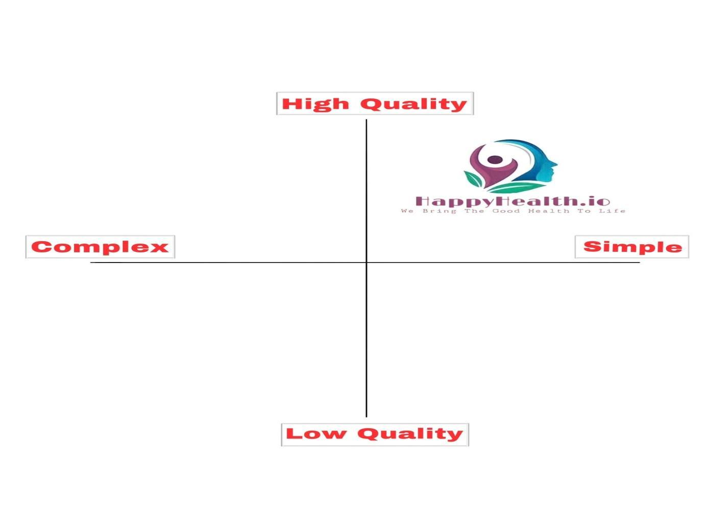

HappyHealth.io position in the market as simple and not complicated, and with the high quality. HappyHealth.io deals with creating awareness to the community about the health tips and best ways of maintaining quality health.

**Marketing Objectives**

1. Increase Customer Lifetime Value

We focus on increasing the average amount that each customer spends with us to provide more value to our existing customer base. But it can also be an easy way to impact our sales with less effort because the relationship is already built. We will

build a company with something that we have to do more than what the consumer expects so the company will have loyal customers.

1. Increase Website

One major goal of brand-awareness campaigns is to increase website traffic. You might be looking to get more eyes on your blog, product pages, or company announcement, but you can’t do this if people don’t know about your brand or

how to find your digital properties. This is where brand awareness comes in. You might, for example, launch a brand-awareness campaign of sponsored, native

articles. You target audiences who might be interested in these articles, entice

them to click, and drive traffic back to your website.

1. Shorten the sales cycle

It’s not just up to the sales team to be more efficient or effective with their conversations, marketing can help shorten the sales cycle too. Because modern prospects get so much information before talking with sales, it’s marketing’s job to deliver consistent messaging, branding, and relevant materials to help them progress toward making a purchase.

**Happyhealth.io Marketing Mix**

Happyhealth.io is a health application that offers you a best service than other health apps. Below are some of reasons why we say so.

**Product**

Happyhealth.io designs, develops, and sell consumer health application and online services.

Happyhealth.io can assist individuals in monitoring their health, it also allow healthcare providers to share and report on a patient's personal health records remotely, and it helps keep track of the user’s lifestyle.

**Price**

Happyhealth.io uses a premium pricing for service app. Because of the best services and continuously introduce innovated services , users tend to subscribe for a premium account. Consistently deliver the better services at a better price. We regularly review the market, run promotions, and adjust prices to maintain our competitive position. This premium pricing strategy attracts consumers and helps maintain the sales and image of the company.

**Place**

HappyHealth.io available in play store and app store to get services in front of the consumers that are the most likely to install and buy them. Services placement including a service on television shows, in films, or on web pages in order to garner attention for the service app. We decided to place our company in a city for them to easily find if they need to go there for important reason or queries or call us that indicated in our web page.

**Promotion**

HappyHealth.io promotes products through advertising. We can promote our product through creating videos on why they should install our application, and how they help them especially during this pandemic.Consumers will not know our brand; therefore, we will have to advertise more aggressively to achieve brand awareness.

**Legal factors**

A government’s rules and regulations—its laws—will always have a macroeconomic impact on the success of any business. And, for our company that operate within the jurisdiction of multiple governments, business leaders must pay attention to the legal factors within each location. As used in this post, the term “government” may refer to a national, state, municipal, provincial, or any other authority that has the ability to make laws, rules, and regulations. Our business operates out of one or more locations and sells its products to buyers in other location, our company will be subject to the laws of more than one government.

**Environmental**

Sustainable marketing is the promotion of environmental and socially responsible products, practices, and brand values. If you’ve ever spent a little bit more on something because you know it was locally sourced or 100% recyclable, you’ve experienced sustainable marketing. These services may be environmentally friendly in themselves or produced in an environmentally friendly services tend to be more expensive than those made overseas using cheap labor, but they have a much smaller carbon footprint because they don't have to fly across the globe to get here.